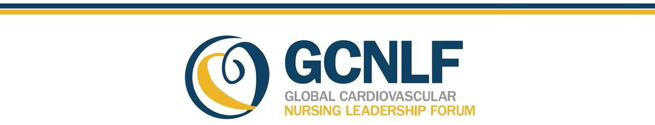

Promoting Nurses Globally as Leaders in Cardiovascular Disease Prevention & Management

## Global Cardiovascular Disease (CVD) Risk

CVDs (stroke and coronary heart disease) are the number one cause of death globally.

* 17.7 million people died from CVDs in 2015, representing 31% of all global deaths.
  1. million were due to coronary heart disease (CHD) and 6.7 million were due to stroke.
     + 3/4 of CVD deaths take place in low- and middle-income countries. 1
* Most cardiovascular diseases can be prevented by addressing behavioral and psychosocial risk factors: 2
  + Risk factors include tobacco use, unhealthy diet, obesity, physical inactivity, stress and depression and harmful use of alcohol.
* According to the United States Centers for Disease Control and Prevetion, 80% of deaths from CHD can be attributed to preventable CHD risk factors.2

## Global Health Workforce

* There were 43 million global health care workers in 2015: 10 million MDs, 21 million nurses, and 12 million community health workers.
* It is estimated that by 2030, the shortage of healthcare workers globally will be about 17.4 million, of which 2.6 million will be MDs and over 9 million will be nurses and midwives.
* The largest needs-based shortages are in South East Asian and African regions. 3

Community Health Workers

Community health workers (CHW) include community health advisors, lay health advocates, outreach educators, community health representatives, peer health promoters, peer health educators and others who:

* + Promote linkages with local communities
  + Are generally trusted, bilingual, can provide data collection, outreach and case management, and culturally responsive public health interventions
  + Have been shown to be cost effective
  + Are often part of a Heart Care Team (nurse practitioners and CHW)
  + Provide guideline-based care to improve CVD risk factors and perceptions of chronic illness in high risk patients 4,5,6

## The Future of Nursing

The Institute of Medicine report on the future of nursing stated that:

* Mentorship programs are important to accomplish the transformation of nursing leadership and how nurses are viewed by professionals and the public.
* A style of leadership that involves working with others as full partners in a context of mutual respect and collaboration is required.
* Nurses, nursing education programs, and nursing associations should prepare the nursing workforce to assume leadership positions across all levels.
* Public, private, and governmental health care decision makers should ensure that leadership positions are available to and filled by nurses.

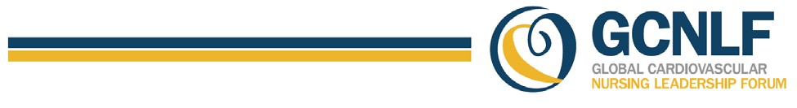

## The Future of Nursing cont.

* Nurses will be increasingly called upon to act as primary care providers.
* Nurses will be asked to help patients manage chronic illnesses.
* Nurses are integral members of multi-disciplinary care teams. 7

## The Global Cardiovascular Nursing Leadership Forum (GCNLF) Supports the Important Role of CV Nurses

Recognizing that nurses and nursing organizations are on the front lines of patient education, [GCLNF](http://pcna.net/gcnlf) promotes nurses as leaders in the prevention of the global CVD epidemic through engagement, mobilization and empowerment of the international nursing community.

Compelling data from clinical trials and meta-analysis support the important role of nursing in CHD and stroke prevention.

* CVD risk reduction efforts should be led by nurse-directed teams that include community health workers, nutrition, counseling, and other services that are located at hospitals, clinics, or community centers 8
* Team-based, guideline-directed, nurse case management has the potential to effect positive change in both primary and secondary prevention of CVD. 9
* All-cause mortality and acute myocardial infarction are improved with secondary prevention programs. Of note, 45% of the clinical trials included in the meta-analysis were nurse led or nurse managed.10

## The World Heart Federation

World Heart Federation members and the Preventive Cardiovascular Nurses Association (PCNA) International Committee, along with individuals and organizations from across the globe, have come together to create the Global Cardiovascular Nursing Leadership Forum (GCNLF).

The activities of the GCNLF support the World Heart Federation goal of a 25% reduction of non-communicable disease mortality by 2025. This 25 X 25 goal requires effort at local, regional and national levels. It requires intensive efforts from all health care practitioners. Nurse leaders in cardiovascular care are uniquely positioned to play a major role in reducing and managing CVD globally. 11

References:

1. <http://www.who.int/mediacenter/factsheets/fs317/en>
2. https:[//w](http://www.cdc.gov/media/releases/2013/p0903-vs-heart-disease.html)ww[.cdc.gov/media/releases/2013/p0903-vs-heart-disease.html](http://www.cdc.gov/media/releases/2013/p0903-vs-heart-disease.html)
3. <http://www.who.int/gho/health_workforce/en>
4. Landers et al. Mounting Evidence of the Effectiveness and Versatility of Community Health Workers. AJHP April 2016; V 104 (4).
5. Kim K et al. Effects of community-based health workers interventions to improve chronic disease management and care among vulnerable populations: systematic review. AJPH 2016(106(4):e3-e28.
6. Allen J et al. Community Outreach and Cardiovascular Health (COACH)Trial: A Randomized Control Trial of Nurse Practitioner and Community Health Worker Cardiovascular Disease Risk Reduction in Urban Community Health Centers. Circ Cardiovasc Qual Outcomes. 2011 Nov 1;4(6):595-602.
7. Institute of Medicine: The Future of Nursing: Leading Change, Advancing Health (2011) Nationalacademies.org
8. [Hayman LL,](https://www-ncbi-nlm-nih-gov.laneproxy.stanford.edu/pubmed/?term=Hayman%20LL%5BAuthor%5D&amp;cauthor=true&amp;cauthor_uid=28806307) [Berra K,](https://www-ncbi-nlm-nih-gov.laneproxy.stanford.edu/pubmed/?term=Berra%20K%5BAuthor%5D&amp;cauthor=true&amp;cauthor_uid=28806307) [Fletcher B,](https://www-ncbi-nlm-nih-gov.laneproxy.stanford.edu/pubmed/?term=Fletcher%20B%5BAuthor%5D&amp;cauthor=true&amp;cauthor_uid=28806307) [Miller NH,](https://www-ncbi-nlm-nih-gov.laneproxy.stanford.edu/pubmed/?term=Miller%20NH%5BAuthor%5D&amp;cauthor=true&amp;cauthor_uid=28806307) [Himmelfarb CD.](https://www-ncbi-nlm-nih-gov.laneproxy.stanford.edu/pubmed/?term=Himmelfarb%20CD%5BAuthor%5D&amp;cauthor=true&amp;cauthor_uid=28806307)Promoting Cardiovascular Health Worldwide: The Global Cardiovascular Nursing Leadership Forum. [J Cardiovasc Nurs.](https://www-ncbi-nlm-nih-gov.laneproxy.stanford.edu/pubmed/28806307) 2017 Sep/Oct;32(5):426-427.
9. Berra K, Miller NH, Jennings C. Nurse-Based Models for Cardiovascular Disease Prevention From Research to Clinical Practice. *J Cardiovasc Nursing.* 2011 Jul-Aug;26(4 Suppl):S46-55 Aug;26(4 Suppl):S46-55
10. Clark AM, Hartling L, VandermeerB, McAlister FA. Meta analysis:Secondary Prevention programs for patients with coronary artery disease, Ann Intern Medicine 2005;143(9):659-672.
11. <https://www.world-heart-federation.org/global-cardiovascular-nursing-leadership-forum-launches-today/>